“ACCOMMODATION AND TRAVEL POLICY”

Seminar on Non-Standard and Precarious Work

8-9 April 2026
Ljubljana, Slovenia

⚠ Please read this carefully as the rules have changed! ⚠

Costs for travel and accommodation will be covered by the ETUC in the context of this project for representatives of the 27 EU Member States and candidate countries. The following measures are essential in order to qualify for reimbursement by the European Commission in the context of activities it co-funds.

Costs for travel and accommodation for this project will be reimbursed using unit costs (not actual costs). However, participants are still required to keep proof of their travel, so it can be checked ex-post by the European Commission audit.

Travel costs will be reimbursed to the participant’s bank account after the event and after the reimbursement form together with the originals of the following documents have been sent to the ETUC by post (*):

- The reimbursement form signed by the participant
- The invoice from the hotel, if any.
- The travel justification document:
- For air travel : all boarding passes (outward and return journeys for each part of the trip). Electronic boarding passes are accepted if they show the QR code.
- Bus or Train travel: the outward and return journey bus or train e-ticket.
- Car travel (for a one-way itinerary of up to 400km): A signed statement mentioning the following elements: name of the event you attended; towns of departure and arrival; car plate number; persons travelling with you if any.

(*) Without these documents or in case of no show, ETUC will not be able to reimburse your travel costs.

1. Accommodation costs

Two nights (in exceptional cases a maximum of 3-nights) hotel accommodation, including breakfast will be covered by the project. In case you need to stay an additional night due to complicated flight schedule, please contact James Hoctor (jhoctor@etuc.org).

You are required to book your own accommodation.

Accommodation costs will be refunded after the event upon receipt of the reimbursement form .
Whether or not you choose to book a room in the hotel(s) suggested by the ETUC, the refund will be for a set amount of 113 EUR.

All extras and personal expenses are payable by participants and will not be covered by the
ETUC.

2. Subsistence costs:

The Daily subsistence allowances (DSA) are paid in addition to costs for accommodation/travel, to cover the costs of meals and other incidental expenses (such as local travel – to/from the airport to the meeting venue / hotel).

For attending the whole duration of this event, you will receive a maximum allowance of 84 EUR for incidental expenses. The DSA given will be adjusted depending on the catering costs.

3. Travel costs

According to the new financial rules for EU grant applications, travel costs will not be reimbursed on the basis of real costs, but as lump sums/unit costs, depending on the distance travelled.
Methods to calculate the amount reimbursed are explained below.

For return travels between 50 and 400 KM: land travel will be required.
Please refer to the tables below to know the lump sum you will be entitled to (intra or international):

- For Intra-member state (within a country):

Country | Amount in EUR Per Return Trip |  | Country | Amount in EUR Per Return Trip |  | Country | Amount in EUR Per Return Trip
AT | 60 |  | ES | 52 |  | LV | 16
BE | 46 |  | FI | 36 |  | NL | 49
BG | 12 |  | FR | 64 |  | PL | 20
CZ | 20 |  | HR | 36 |  | PT | 40
DE | 64 |  | HU | 28 |  | RO | 16
DK | 76 |  | IE | 36 |  | SE | 56
EE | 16 |  | IT | 52 |  | SI | 27
EL | 36 |  | LT | 20 |  | SK | 20

- For inter-member states (between two countries):
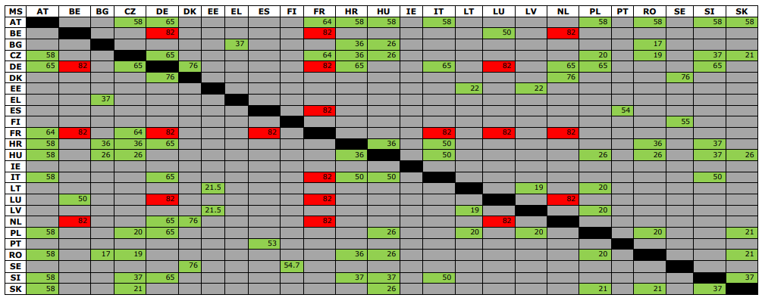

For return travels of more than 400 km: you can either:
- Travel only by air
- Travel only by train
- Combine both

For these travels, please refer to the table below to know the lump sum you will be entitled to:

Distance band  (in km) one-way trip | Amount in EUR per Return Trip |  | Distance band  (in km) one-way trip | Amount in EUR per Return Trip
400-600 | 245 |  | 2501-3500 | 541
601-800 | 261 |  | 3501-4500 | 659
801-1200 | 276 |  | 4501-6000 | 796
1201-1600 | 288 |  | 6001-7500 | 900
1601-2000 | 369 |  | 7501-10000 | 1.201
2001-2500 | 429 |  | 10001-Max | 1.376

All distances to be measured using either the rail or flight calculator at the following website: https://ec.europa.eu/info/calculate-unit-costs-eligible-travel-costs_en

For example: a meeting takes place in Berlin and you depart from Brussels. Then you take the distance calculated by the website (Brussels to Berlin is 640km), and this one-way distance gives you the corresponding band to define the lump sum you are entitled to. In this case (640km) the amount for your return trip is 261€.

This is the one way distance between the departure and arrival point, corresponding to the amount for the return journey.

