Throughout Europe, minimum wages are an established tool of labour market regulation. They play a particularly important role in raising wages. However, there are considerable differences in the procedures and institutions used to determine the minimum wage. The existing minimum wage regimes across Europe can broadly be grouped into two categories. On the one hand there are universal minimum wage regimes which define a general wage floor usually at the national level and in most cases on a statutory basis. On the other hand, there are sectoral minimum wage regimes which set a minimum wage for specific branches and/or occupations usually on the basis of a collective agreement. Some member states combine elements of these systems.
Within the EU, 22 out of 28 member states have a universal regime with a nationwide statutory minimum wage rate. In six member states there are sectoral minimum wage regimes, including the Nordic countries Denmark, Finland and Sweden as well as Cyprus, Italy and Austria. In this second group of countries – with the exception of the special case of Cyprus where there are statutory minimum wages for certain occupational groups – minimum wages are solely determined by collective agreements.
Minimum wages across Europe not only differ with respect to their institutional regime but also with respect to their absolute and relative levels. Due to the highly diverse economic and social framework conditions, it is difficult to compare absolute levels of minimum wages. A more telling indicator therefore is the relative level which measures minimum wages in relation to the overall wage structure as a percentage of the national median or average wage. Figure 1, which is based on OECD data, provides information on the relative level of minimum wages for 19 out of the 22 EU countries with a statutory minimum wage. Unfortunately, the OECD database does not include any information on Bulgaria, Croatia and Malta.

Figure 1: Minimum wage as % of national full-time median and average wage (2016)
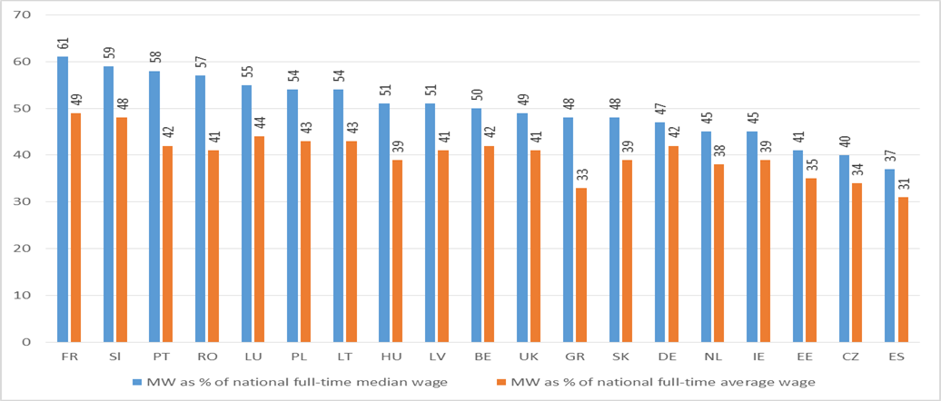
Source: OECD Stat.
Figure 1 reveals that even though over the last three years, some progress has been made in raising minimum wage levels across Europe, the relative level of minimum wages measured as % of the national median and/or average wage is still very low. In all 19 EU countries with a statutory minimum wage, for which the OECD provides data, it remains below the low-wage threshold which the OECD and other international organisations set at two thirds of the national median wage. The fact that in all these 19 EU countries the statutory minimum wage remains below the low-wage threshold confirms recent Eurostat findings that in 2014, in the European Union, one in six employees (or 17.2%) was a low-wage earner.
Since one of the key objectives of minimum wages is to make a contribution to keeping workers out of poverty it is particularly worrying that in 10 out of the 19 countries covered in figure 1 the relative level of the minimum wage falls below 50% of the national median wage. Even though in-work poverty can be attributed to a variety of factors – such as insufficient working hours or the number of household members to be supported – the low level of minimum wages is an essential factor that contributes to many people across Europe not being able to make a living from the money they earn.

Figure 2: National MW per hour 2017 compared to hypothetical MW of 60% of average and median wage (in Euros)
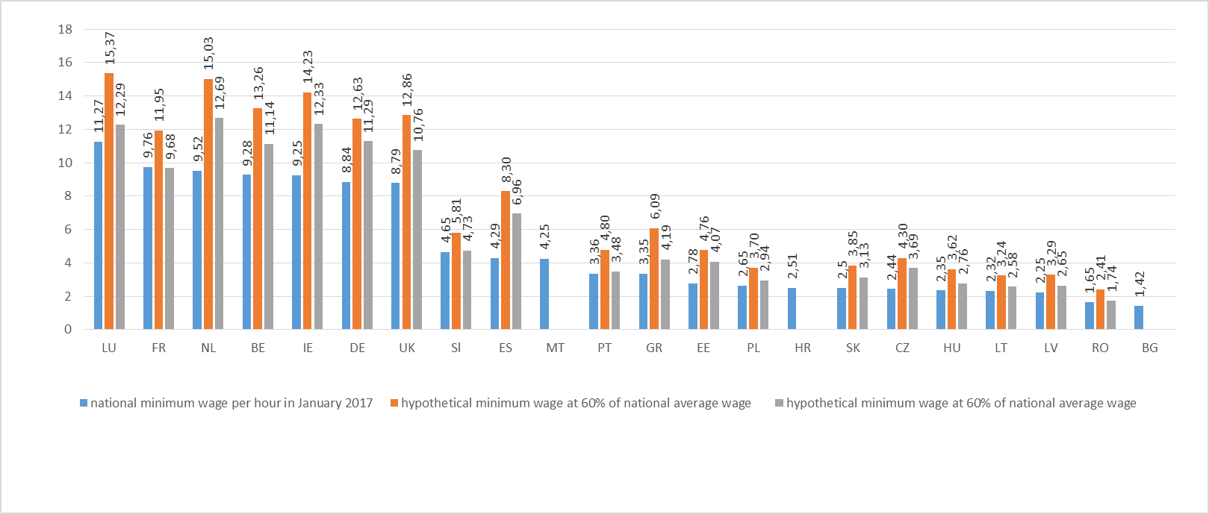
Source: own calculations based on WSI Minimum Wage database and OECD Stat.
Thus, for minimum wages to make a meaningful contribution to preventing in-work poverty and to more dynamic overall wage growth, minimum wages need to become living wages that ensure workers a decent living standard and the satisfaction of their needs and those of their families – as stated in the European Pillar of Social Rights. There are a number of steps towards achieving these objectives. In 2008 already, the European Parliament in a resolution to promote social inclusion and combat poverty called on the European Council to agree a common EU target for minimum wages. This target should ensure a remuneration of at least 60% of the relevant average wage. In its 2016 report on social dumping, the European Parliament repeated this demand calling for a minimum wage target of “at least 60% of the respective national average wage …, to avoid excessive wage disparities, to support aggregate demand and economic recovery and to underpin upward social convergence”. In a similar manner, the ETUC demands in its most recent resolution “for a common strategy on low and minimum wages” that all statutory minimum wages should be living wages of no less than 60% of the national median or average wage – whichever is more favourable to the workers.
Figure 3, which compares the actual statutory minimum wage with a hypothetical minimum wage of 60% of the national average wage, illustrates that in all the 19 EU member states with a statutory minimum wage for which the OECD provides data, considerable increases are needed to achieve this objective. The increases in real terms range from less than 1 euro in Romania and Lithuania to more than 5 euros in the Netherlands.
However, due to the large variation in the absolute levels of minimum wages, even more telling is the relative increase in percentage points needed to achieve 60% of the national average wage. As figure 3 illustrates, an increase of 0,76€ in Romania and an increase of 4,07€ in the UK both amount to a 46% increase due to the highly different absolute level of the statutory minimum wage. Overall, figure 3 illustrates that the increases needed to achieve 60% of the respective national average wage range from a bit more than 20% in France and Slovenia – the countries with the highest relative level of minimum wages - to more than 90% in Spain.
Figure 3: Minimum wage increases needed to achieve 60% of national average wage (in % and in absolute terms)
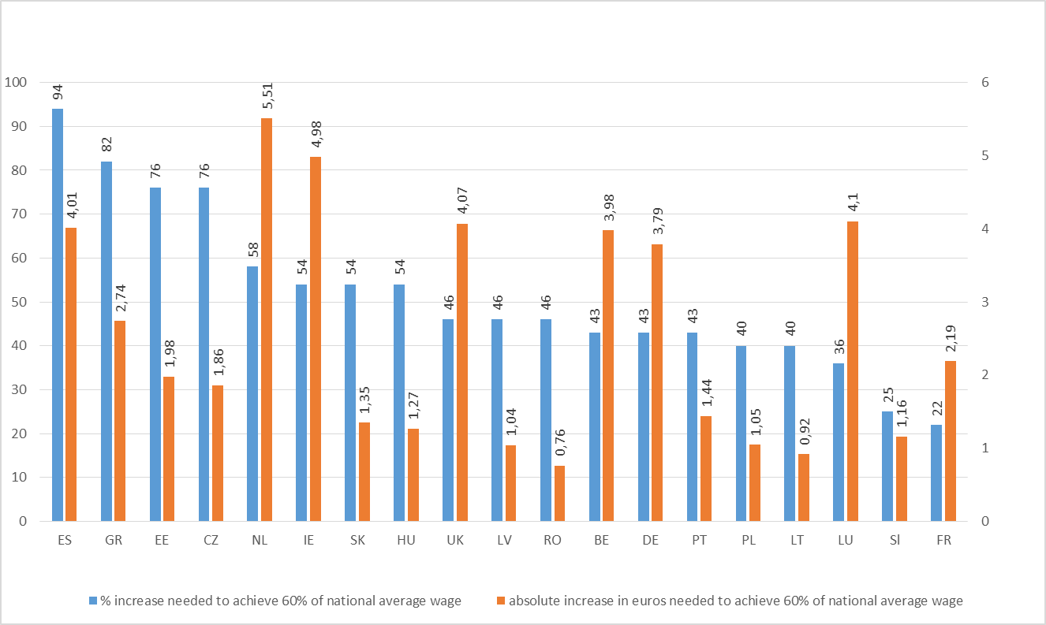
Source: own calculations based on WSI Minimum Wage database and OECD Stat.
Since it would be difficult to achieve such large minimum wage increases in the short and medium term and in order to avoid negative employment effects, one could imagine a two-stage process of minimum wage increases. The first stage would be to bring minimum wages up to a level of 60% of the national median wage. Figure 4 below illustrates that the increases needed to lift minimum wages to this level are much more modest than the ones needed to achieve 60% of the average wage. Once the countries achieved the level of 60% of the national median wage, the second stage could be to aim for a gradual increase to 60% of the national average wage.
The example of Portugal and Romania illustrate why this second step is needed. In these two countries the fairly high level of minimum wages in relation to the national median wage is the result of an unequal wage distribution, with a high concentration of wage earners at the bottom of the wage scale. In other words, in these two countries the whole wage scale is so low that the seemingly high minimum wage level in relation to the median wage is still not enough for workers to make a living from what they earn. Thus, 58% of a very low median wage in Portugal is still a very low minimum wage in absolute terms even though statistically it seems fairly high.

Figure 4: Minimum wage increases needed to achieve 60% of national median wage (in % and in absolute terms)
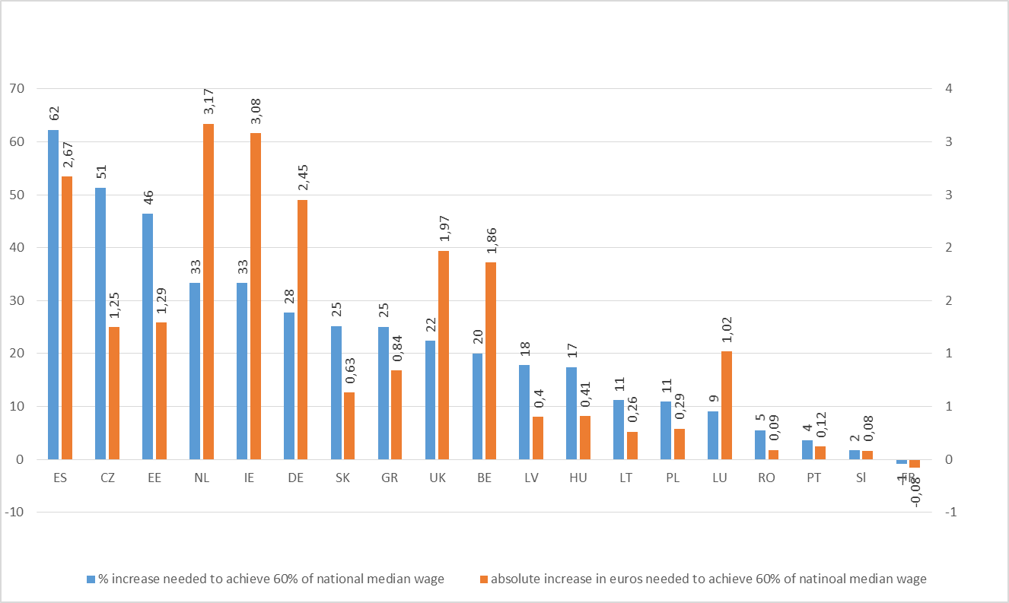
The examples of Portugal and Romania illustrate two things: first, it is important to go beyond 60% of the national median wage for minimum wages to make a meaningful contribution to preventing in-work poverty; and second, minimum wage increases alone are not sufficient. A European minimum wage policy needs to be complemented with measures to strengthen multi-employer collective bargaining and collective bargaining coverage in order to stabilise and raise the whole wage structure and in order to change the unequal wage distribution.
A European minimum wage policy involving a two-stage process of minimum wage increases based on the definition of common European targets would be an important element in pushing forward a new perspective which views wages not only as a cost factor, but which also acknowledges the important role of wages in boosting internal demand and in fostering social cohesion. By defining a floor of adequate minimum wages and by compressing the overall wage distribution, such a European minimum wage policy would make an important contribution to reducing in-work poverty and inequality – and would be an important step in making minimum wages living wages.
The wage increases linked to the introduction of such a common European target would, furthermore, promote economic growth – in particular since workers at the lower end of the pay spectrum show a greater propensity to spend the additional money they earn. Since, furthermore, women are disproportionately overrepresented in the group of minimum wage earners, a substantial increase in the minimum wage level would also help to reduce the gender pay gap across Europe.
It is obvious that in some countries, where the gap between the actual minimum wage and the two targets are particularly large, it is difficult to achieve the large increases needed to realise the objective of 60% of the national median or average wage in the short run. However, as a longer-term objective such common targets would serve as an important reference point for future policies both at national and European level. The common targets of 60% of the national median and average would breathe life into the commitment made in the European Pillar of Social Rights as regards “fair wages” and “adequate minimum wages”. The European Semester and the country specific recommendations could be used to implement this objective in order to achieve higher wages in Europe; even more urgent since currently more and more international institutions such as the European Commission, the European Central Bank and the IMF emphasise the need for more dynamic wage growth to achieve more sustainable growth and to prevent deflationary tendencies.
However, it is important to emphasise again that common targets for statutory minimum wages can only be one element in achieving higher wages in Europe. It needs to be accompanied by initiatives to strengthen multi-employer bargaining structures and increase collective bargaining coverage, which are essential to more dynamic growth in wages across Europe. Further work is needed to achieve living wage targets.
In view of the current crisis of legitimacy afflicting European politics in most European countries, a European minimum wage policy based on common European targets could represent a definite political project for reviving the idea of a social Europe, thereby helping to win back EU citizens’ confidence and belief in the value of European integration.

The median wage is the wage that divides the wage structure into two equal segments; i.e. it marks the boundary between the highest paid 50% and the lowest paid 50% of all employees. By contrast, the average wage represents the arithmetical mean of all wages.

